Sauteed Zucchini, Mushrooms and Parmesan Cheese
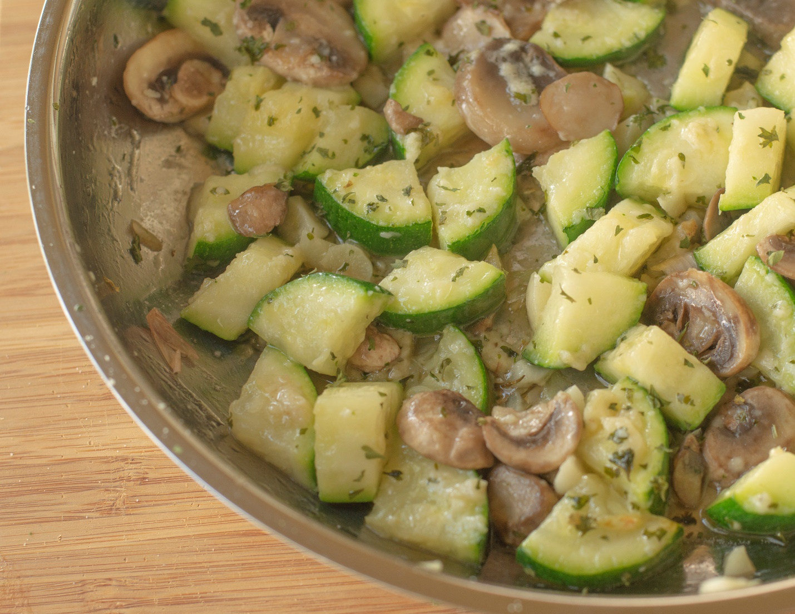

INGREDIENTS
- 2 Tablespoons unsalted butter
- 2 – 3 cloves of minced garlic (optional)
- 1 medium zucchini
- 1 cup sliced mushrooms
- ¼ Teaspoon dried parsley
- Pinch of ground black pepper.
- 1/8 cup grated parmesan cheese

DIRECTIONS
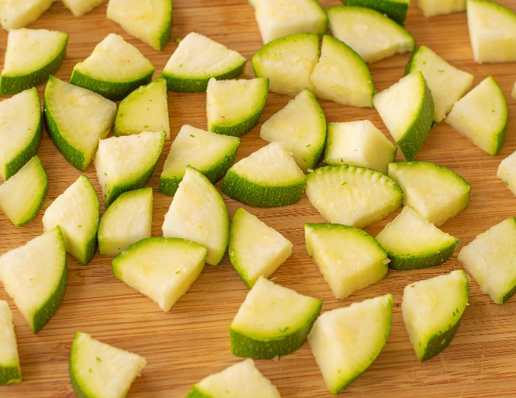
- Wash and slice the zucchini.
- Melt the unsalted butter in a large skillet over medium heat.
- Once the butter has begun to bubble, add minced garlic and sauté until fragrant (about 2 – 3 minutes) Do not overcook the garlic.
- Add the zucchini and mushrooms and parsley. Sauté for about 5- 7 minutes over medium heat. The zucchini should be fork tender but not mushy.
- Turn off the heat and stir in the parmesan cheese.
- Top with freshly grated black pepper and more parsley.
- Enjoy.

